**CURRICULUM FRAMEWORK**

CFW.IAE.EDUCATION

CHANGES & ENHANCEMENTS

1. Course / Branch Name must be a dropdown instead of a text box. (2 hrs) - DONE
2. Courses / Branches will be entered by super admin to populate in this drop down. (4 hrs) - DONE
3. So the linking will be changed accordingly. (B.Tech to Civil Engineering, Civil Engineering to Subject Categories) (3 hrs) - DONE

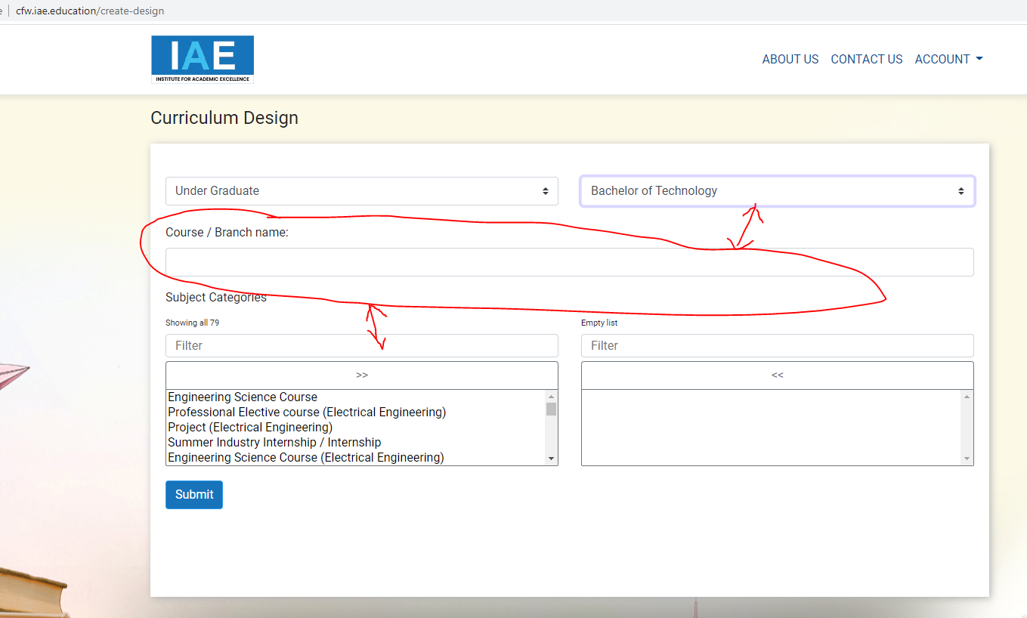

1. Increase the height of those listing boxes. (unable to see the list with in the small box) (1 hr) - DONE

INCREASE THE HIEGHT MORE THAN DOUBLE - DONE

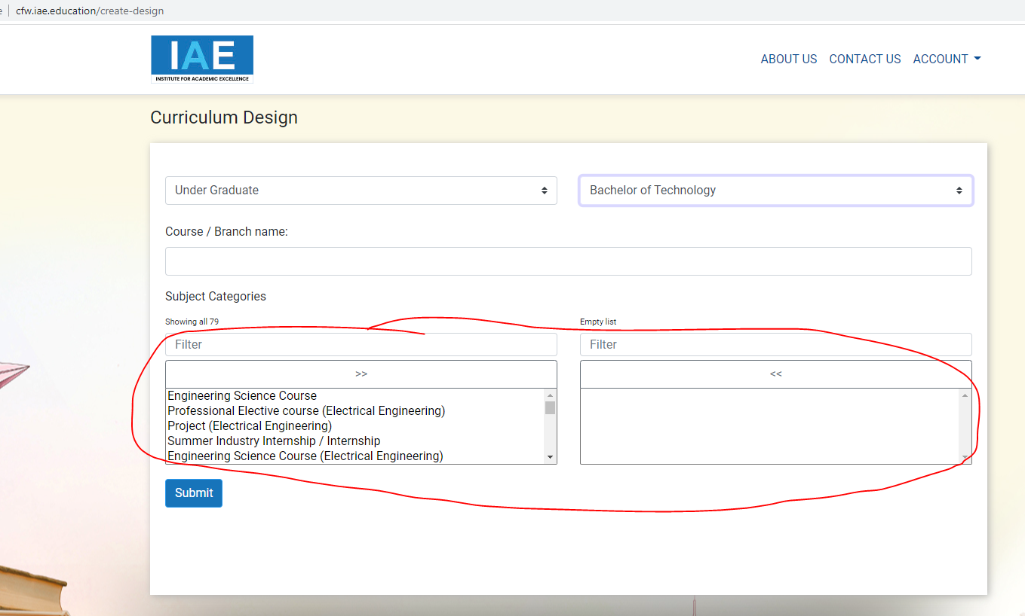

1. Typical Credits are to be shown here which are entered by Super Admin. And the credits entered by the institution should be shown here separately.DONE

**The Credits entered by the institution is shown under the Typical Credits**

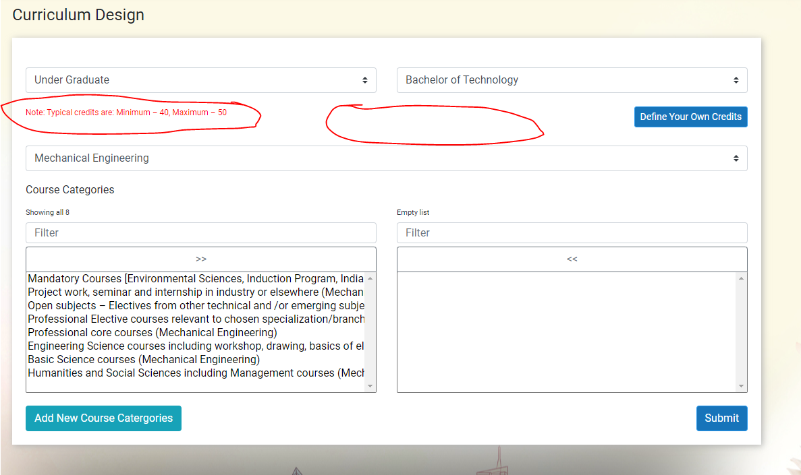

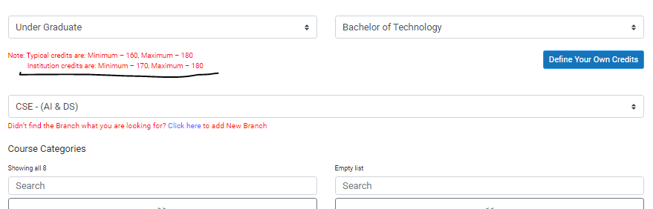

1. There must be an option for user (institution) to add a new value if it is not there in the list. That value must be saved in the master table and shown to all the users. (5 hrs) - DONE

Add New Branch option should be below the dropdown, (Didn’t find the Branch what you are looking for? Click here to add New Branch) -- DONE

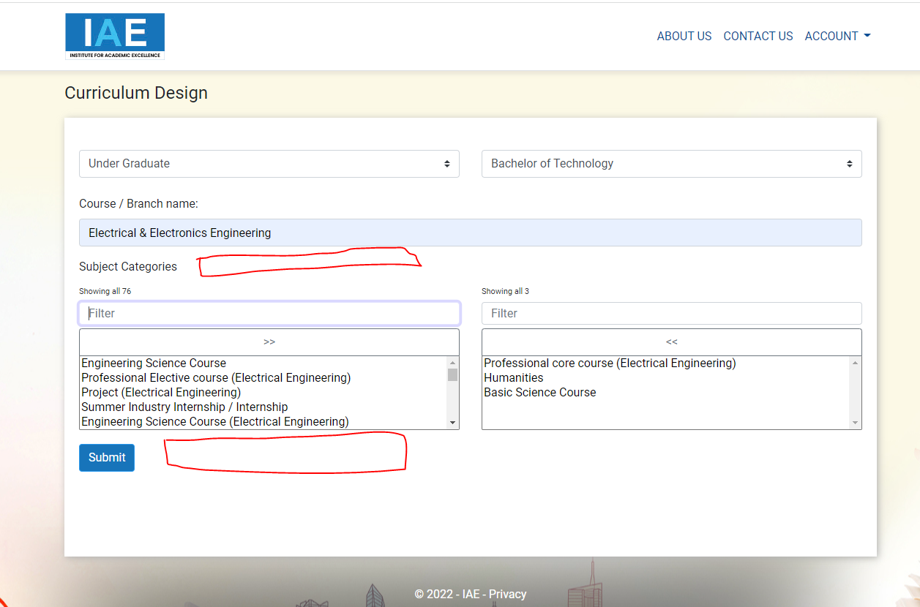

1. In this screen, list is showing in descending order, it should show the first select in serial no.1, second selected in slno. 2… (1 hr)- (NA)DONE - SHOWING IN ALPHABETICAL ORDER BECAUSE ABOVE IS NOT POSSIBLE

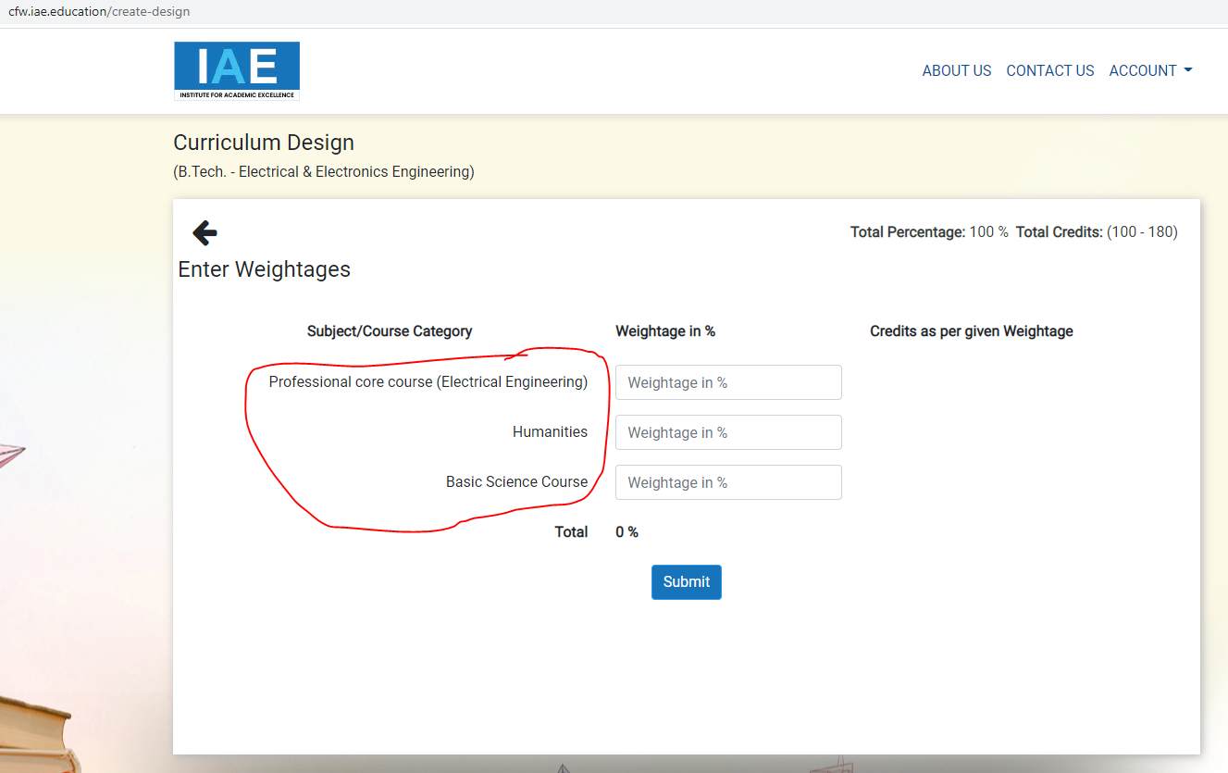

1. Please provide the option to user(institution) to define Minimum & Maximum Credits in the following screen. And consider this for this particular course in the next screens to calculate credits. (10 hrs) – DONE

Note: Typical credits are: Minimum – 100, Maximum – 180 -> ( update credits in course level & individual inst level)

Define your own credits -> button

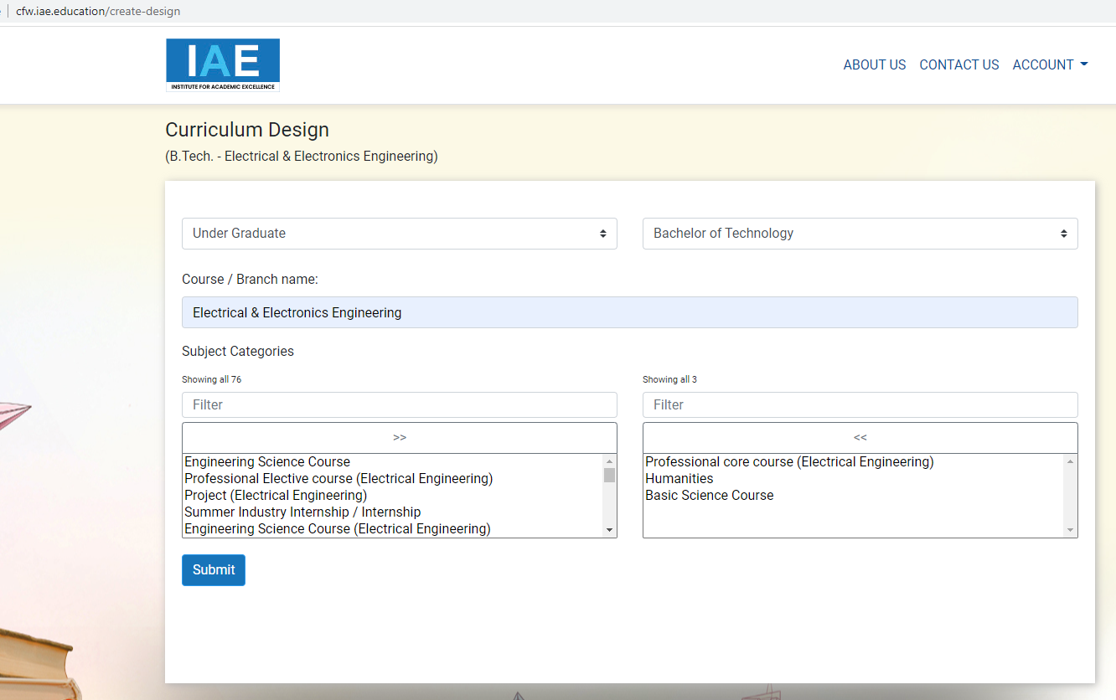

1. Change the text of labels (1 hr) - DONE
   1. Subject Categories as Course Categories - DONE
   2. Filter as SearchPENDING -- DONE

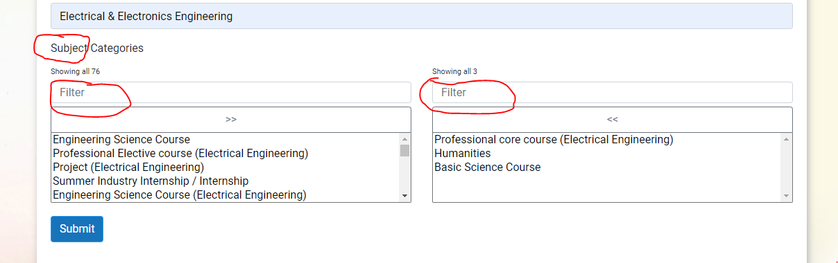

1. **Provision should be given to the user (institution) to define the credits for 1 hour Lecture, Tutorial and Practical. Below is an Example. (6 hrs)**–DONE

|  |  |  |
| --- | --- | --- |
|  | **Hour/s** | **Credit/s** |
| **Lecture** | **1 =** | **1** |
| **Tutorial** | **1 =** | **1** |
| **Lab/Practical** | **2 =** | **1** |

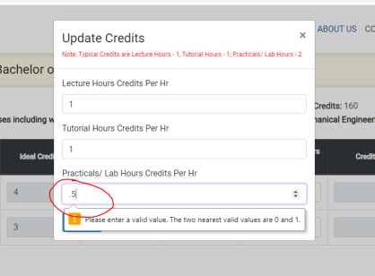

fractions not accepting. - DONE

**It is accepting decimal values**

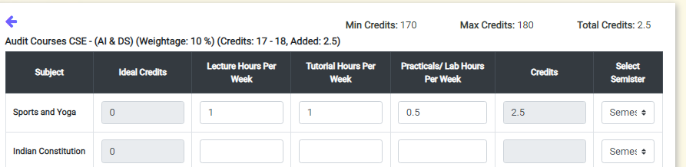

1. Please check the Alert message: - DONE

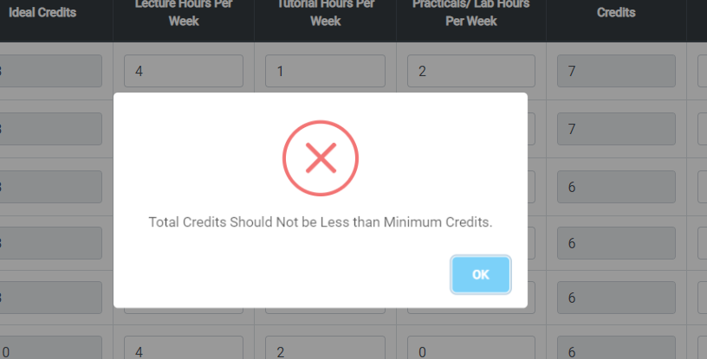

1. In the below screen, it is showing the total of the entered weightages, also show the remaining weightage while entering. (8 hrs) - PARTIALLY DONE
   1. Also, show a pie graph chart according to the weightages.**MISSING**
   2. Some times Mandatory course may or may not have the credits but we need to enter the number of Lecture, Tutorial or Practical Hours, consider this for next screens.**PENDING**
   3. In the same way, some of the courses may not have the L/T/P Hours but will have Credits, make it possible with a solution. **PENDING**

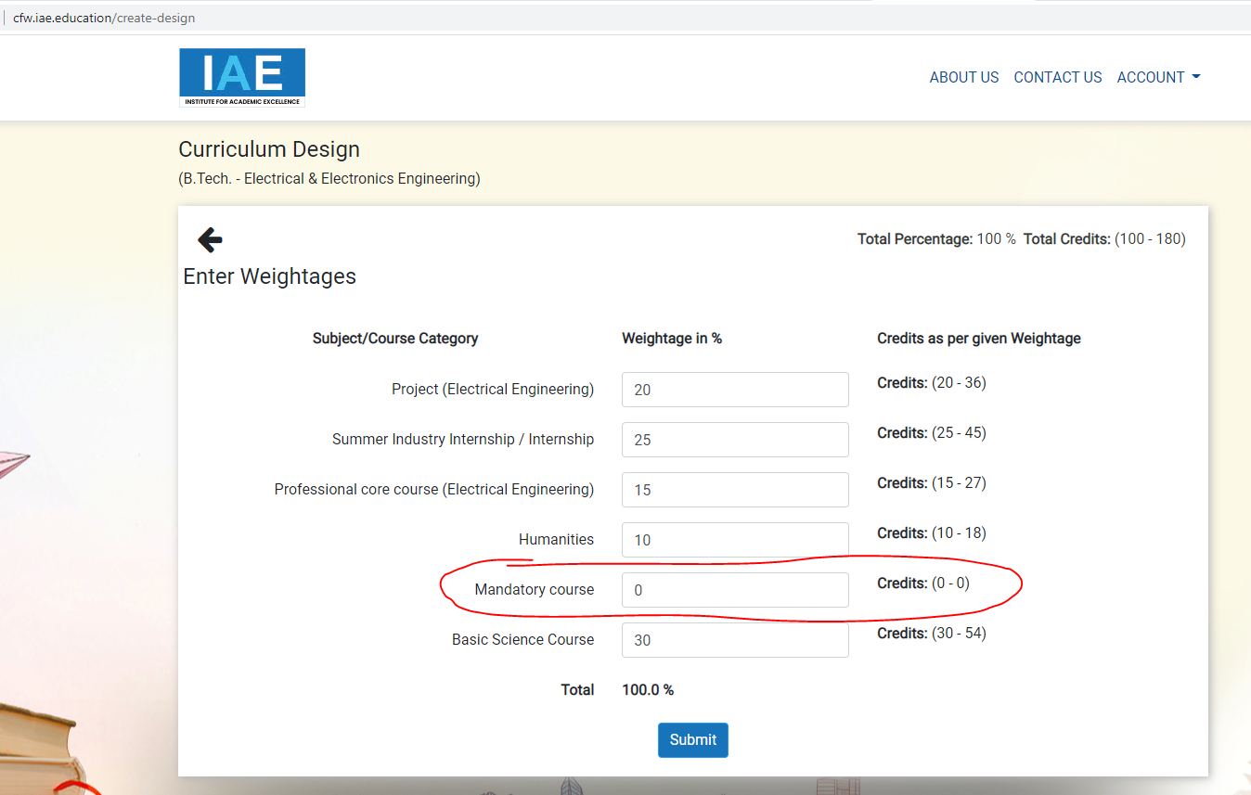

1. In the pop-up, write Course instead of Branch. (30 min)- DONE

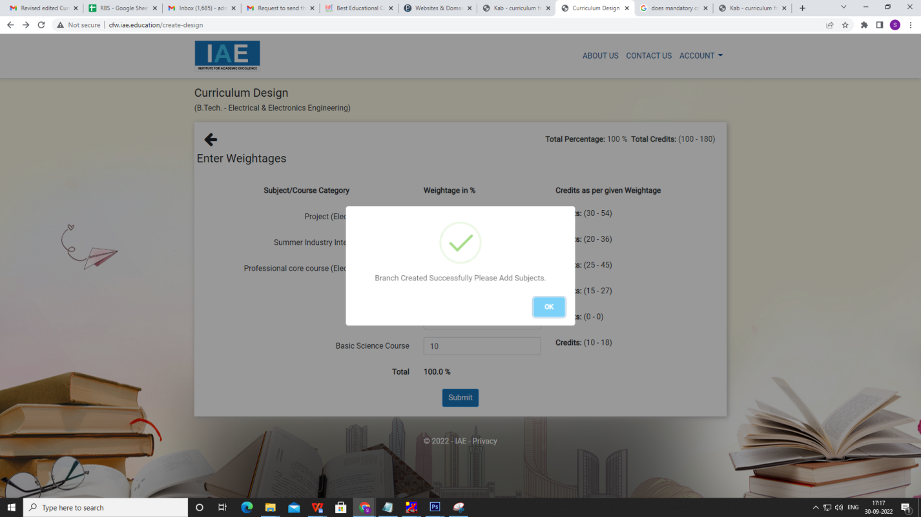

1. In the below screen, provide an option to user to add subjects if not available in the list. Those subjects will be added in master table and visible to other users too. (6 hrs) -DONE

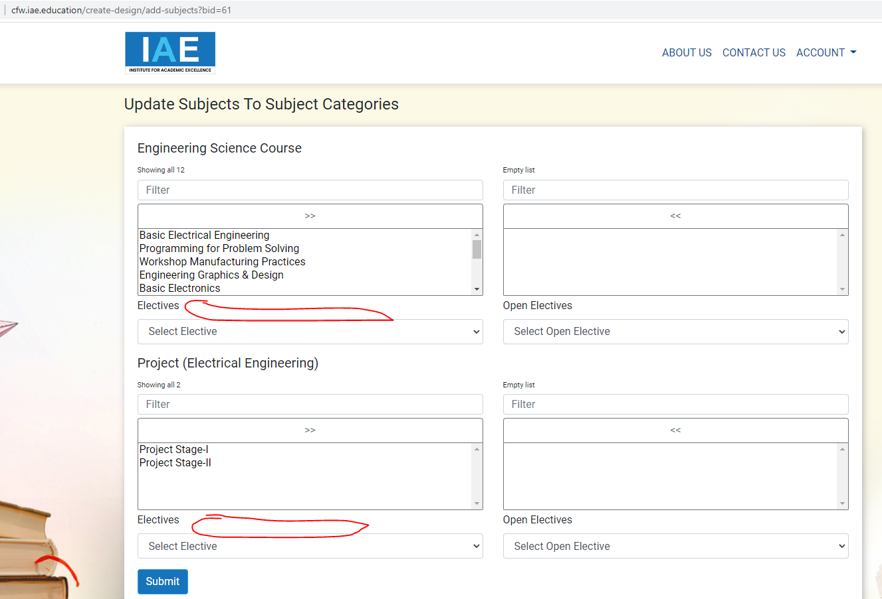

1. There is no back button on any page to go back, Pls provide. Pls save the data in every page other wise if we go back it is going to first page and entire work is not getting saved. If we save the data in every page, user can continue later whenever he get time. (3 hrs) - PARTIALLY DONE

**When we click on back button it is not taking to the previous page but to the first page**

1. **ISSUE:** if we enter into edit mode and update the course, then there are few duplicate records showing in the list as shown in below screenshot, showing the same subjects multiple times in subject selection screen, please fix this issue. (2 hrs) - DONE

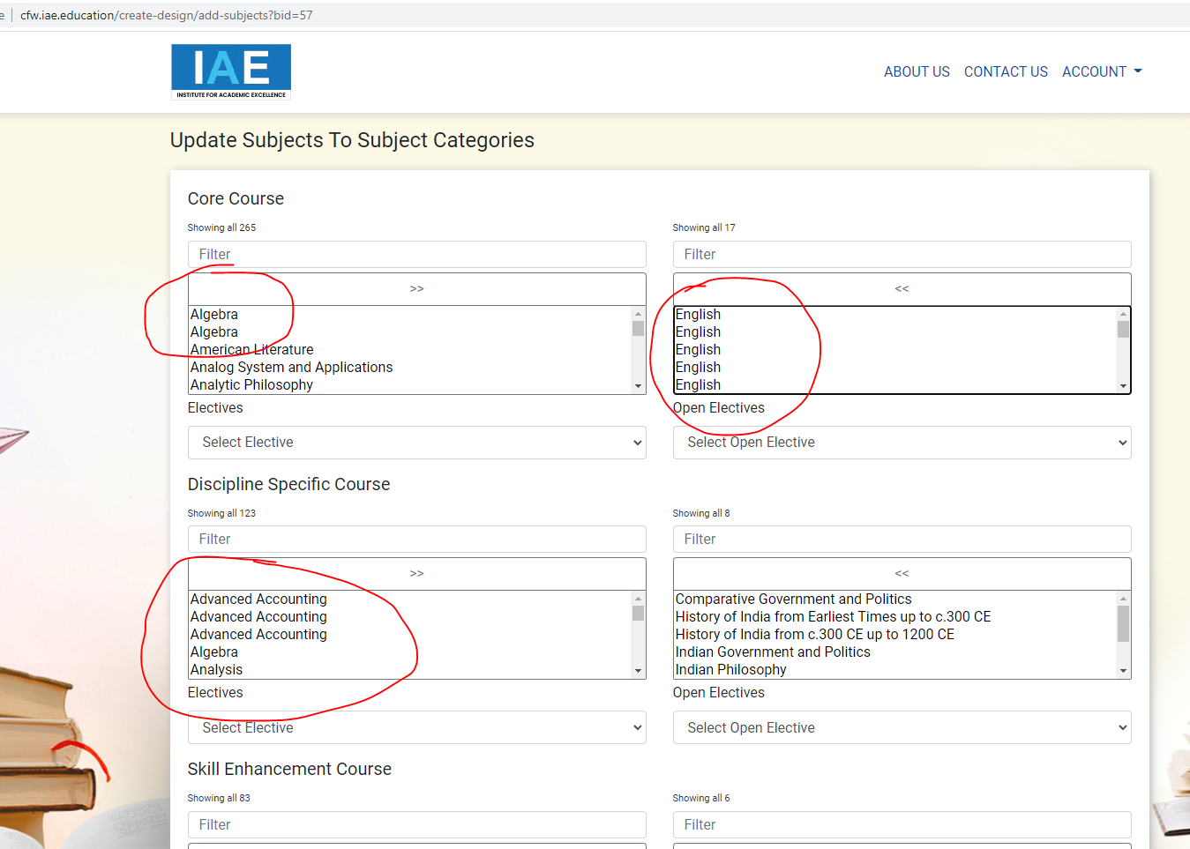

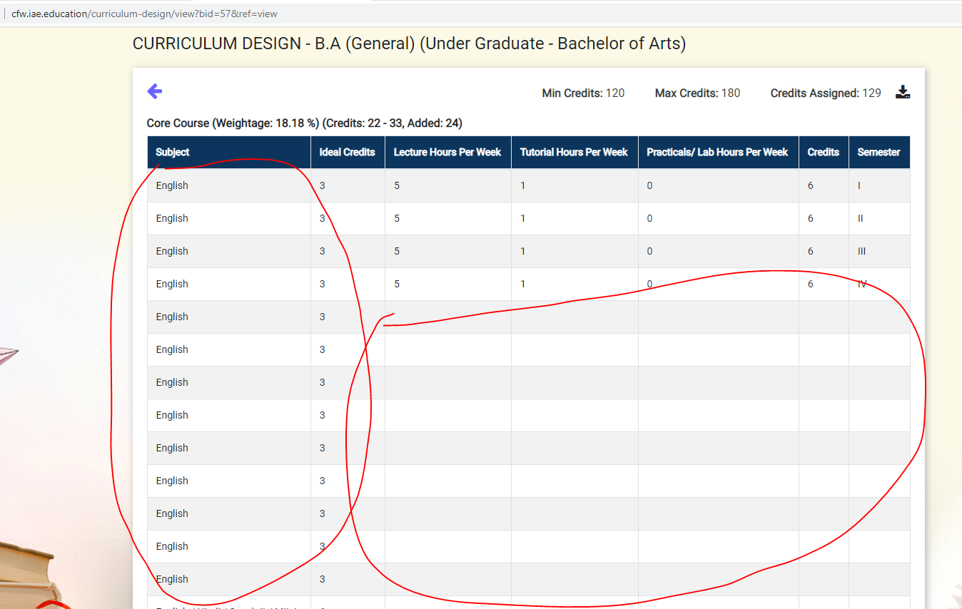

1. **ISSUE:** if we click on download pdf button, a pdf is download but it is not properly aligned, there is not table and lines, just text is displayed in it, pls fix it. Check the below screen shot.(4 hrs) - PARTIALLY DONE

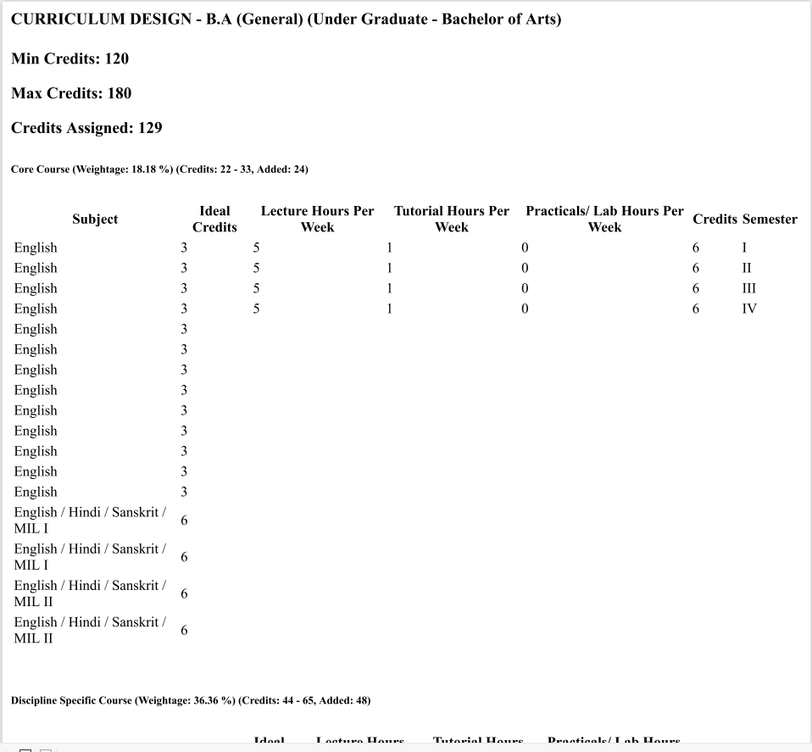

1. Pdf file must show the name of the college. (30 min) – **PENDING –( Done)**
2. Add totals in the semester wise pdf–**PENDING** 3hrs(Done)

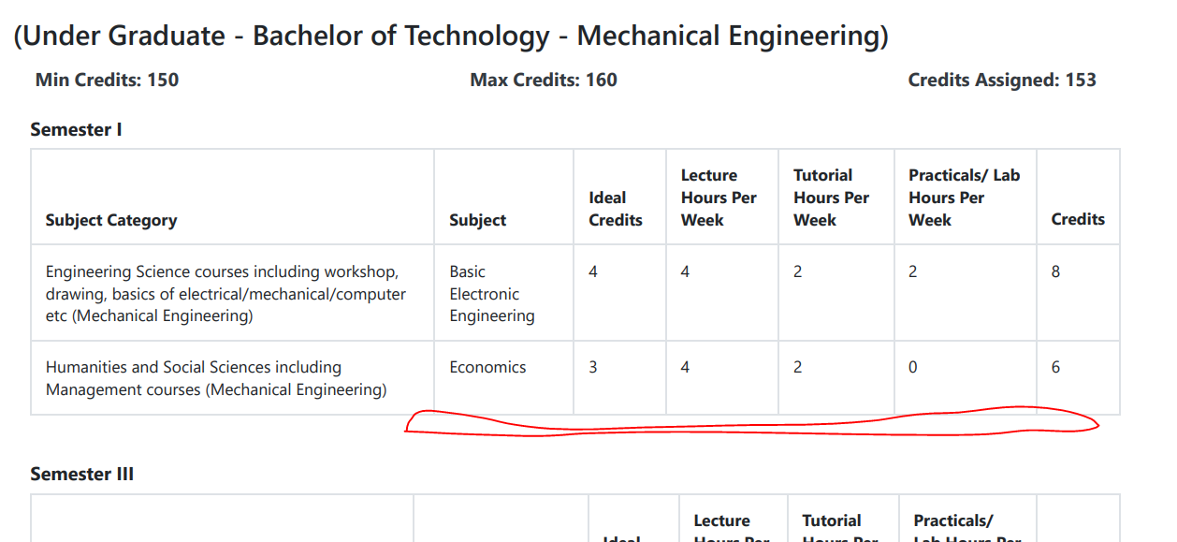

1. Course name must be shown as ‘Under Graduate Program - Bachelor of Arts - B.A. (General)’ (Program - Course - Course/Branch). (2 hrs) - DONE
2. And the above pdf is showing the details course category wise. We need another pdf with semester wise. (10 hrs)THERE ARE ISSUES IN PDF - MENTIONED IN BELOW POINTS
3. Please write the below content in login page below the login button, see the screen shot. (2 hrs)DONE

------------------------------------

Curriculum Framework-Course Planner

Software Tool for Course Sequencing and Credit Distribution.

Designed to meet the requirements of

1. Multiple Entry and Exit
2. Choice Based Credit System (CBCS)
3. NAAC Framework

-------------------------------------------

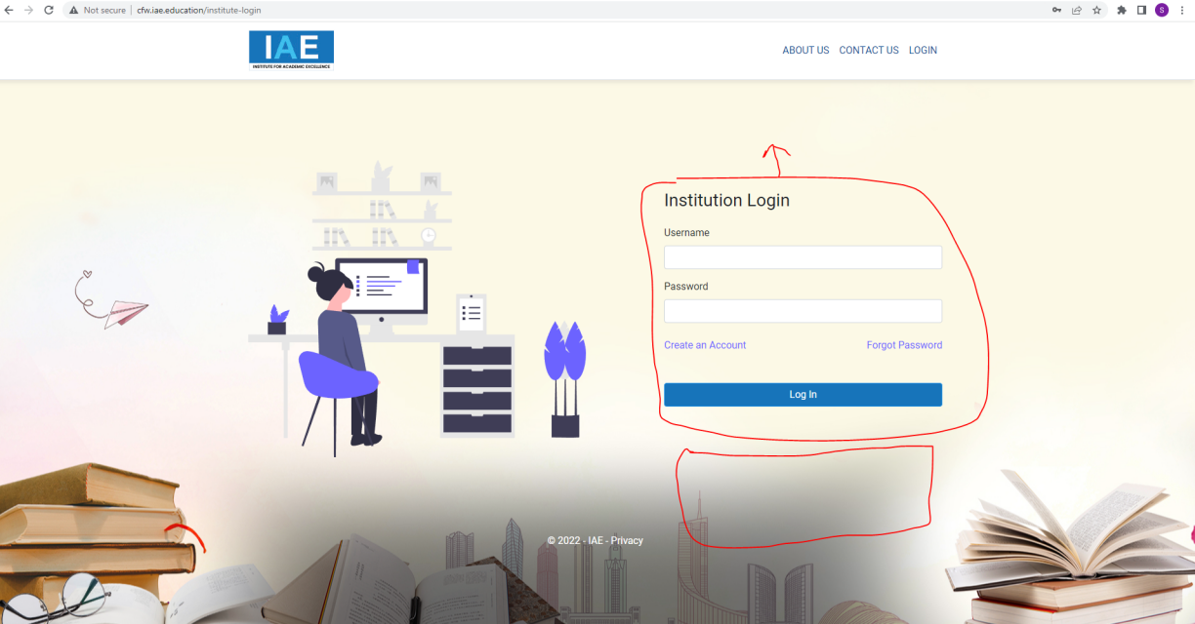

1. While giving provision to user to add course category or subjects the text should be as mentioned below.

Didn’t find what you are looking for? Add here. (With a text box to add it) (1 hr) - DONE

1. A Note must be there in the weightages page: (2 hrs)- DONE

*Minor variation is allowed as per the need of the respective discipline.

1. A pop-up alert must be shown when user giving credits to subjects and assigning semesters, in case the credits are exceeding 20 in a semester it should give an alert. (2 hrs)IT IS GIVING THE ALERT WHEN CREDITS IN THE CATEGORY ARE REACHED 20, BUT IT SHOULD CALCULATE THE CREDITS IN THE SELECTED SEMESTER AND IF THE CREDITS REACHED 20 IN THAT SEMESTER THEN IT SHOULD GIVE AN ALERT.
2. Pop-up while selecting professional electives whether prerequisite is selected in the previous semester or not.**PENDING**
3. Pop-up while selecting Mini Project - Mini Project should be added between 3rd semester and 6thsemester.(4 hrs)**PENDING**
4. Pop-up while selecting Open Electives: Open electives can be added in 3rd Semester to 6thSemester.(4 hrs)**PENDING**
5. Pop-up while selecting Economics for Engineer, Environmental studies, HVPE. ‘Please check work load balance for the available faculty.’ (4 hrs)

**PENDING**

1. Pop-up while selecting Open Elective: Colleges can plan for Track Base / General Pool Open Electives. (2 hrs)

**PENDING**

1. Pop-up(Instructions): DONE

**Note:**

Under Graduate Degree Courses in EMERGING / MULTIDISCIPLINARY AREAS shall be allowed as specialization from the same department. The minimum additional Credits for such Courses shall be in the range of 18-20 (including credit transferred from the SWAYAM platform) and the same shall be mentioned in the degree, as specialization in that particular area. For example, doing extra credits for Robotics in Mechanical Engineering shall earn B.E./B.Tech. (Hons.) Mechanical Engineering with specialization in Robotics.

Minor specialization in EMERGING/ MULTIDISCIPLINARY AREAS in Under Graduate Degree Courses may be allowed where a student of another Department shall take the minimum additional Credits in the range of 18-20 and get a degree with minor from another Department.

**Disclaimer:**

Areas in which Minor Degree/Hons. may be offered are numerous. It is up to the Universities with the help of their Academic Board/Council to decide whether Minor Degree/Hons. is to be offered or not in any particular area, which is not mentioned above. AICTE approval is not required for offering Minor Degree/Hons. in any such area, however the criteria that “Minor Degree or Hons. will cumulatively require additional 18 to 20 credits in the specified area in addition to the credits essential for obtaining the Under Graduate Degree in Major Discipline (i.e. 160 credits)”

To maintain the quality of Education, 60% of the eligible courses in any Technical Institution shall be accredited in the next TWO (2) years’ time, else EoA shall not be issued by the Council.

THIS PARAGRAPHS IS MISSED IN THE ABOVE POP-UP Already added (Done)

1. Pop-up while selecting Professional Core Courses: Professional Core Courses shall be offered during 6th, 7th and 8th Semesters. (2 hrs)**PENDING**
2. Admin should have a provision to make the curriculum design created by any institute visible with a control in admin panel. So that any institution can see that curriculum in their dash board like sample or a model curriculum. A provision should be provided to the institution to use those models If they want to use the same with small corrections and they could be able to modify and save for them. Search facility (Institution shall be able to search by institution or course as per their requirement).**PENDING -> clone framework from another institution**

* Change reports tab -> Reference
* Fields to be displayed -> program, course, branch, institute with search facility

1. Institution should have a provision to share the created curriculum with a link to other persons to cross check and suggest modification in it. Those modification should be indicated with some color code so the institution will check it again and approve/reject the modifications. **PENDING**

Note: we will add if we found anything.

1. The below point is still pending. DONE  **BUT THE GRAPH IS MISSING**

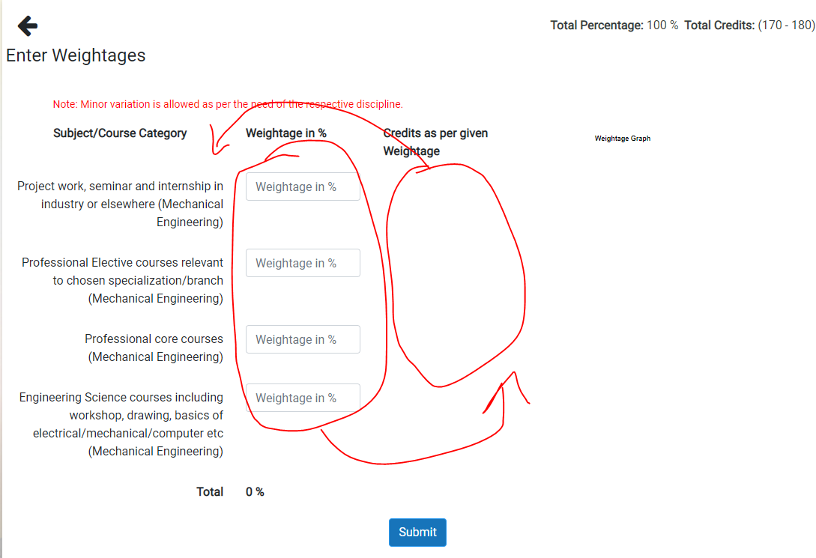

1. Change the Subject as ‘Course’ 30min (Done)

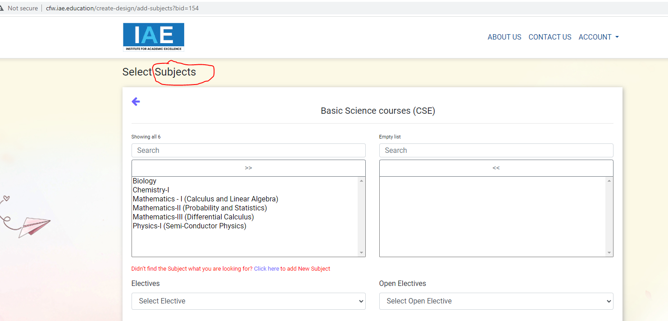

1. Keep a separator between the sections to avoid confusion. 1 hr(Done)

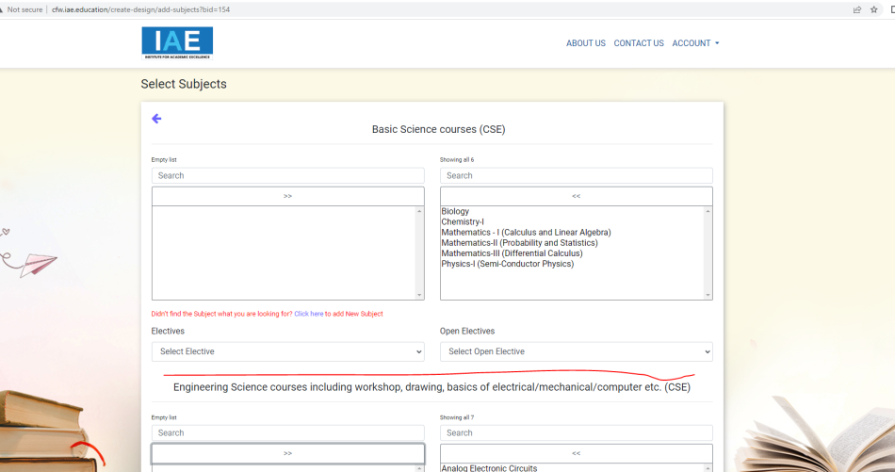

1. In the following screen… 5hr(Done)
   1. Remove brackets to the program name.
   2. Display the weightage and credits in second line.
   3. Display the Total credits in colors(orange if less than min credits, green if it is between min & max credits, red if it exceeds max credits)
   4. Added credits also show in color comparing with defined credits.
   5. Show the totals of L/T/P and Credits.

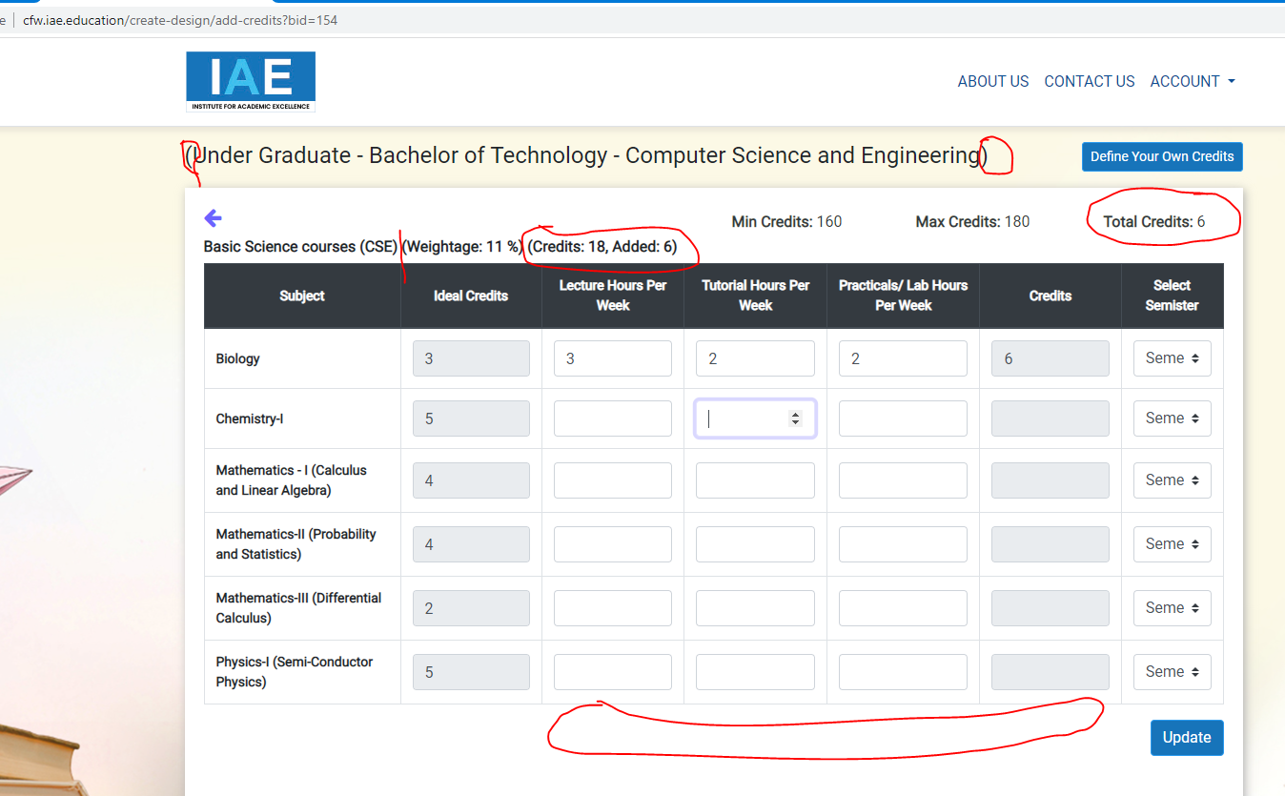

1. Popup showing the message before the count reaches to 20, because I did not select the semester. And the message should be ‘The total credits in Semester-II are reached to 20.’

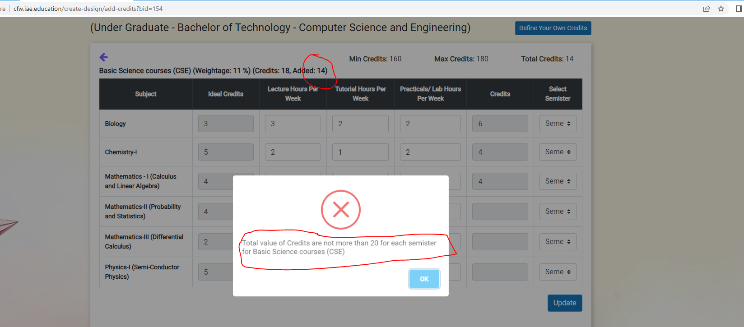

1. Display the Name of the Program, Course and Branch (Ex: Undergraduate Program - Bachelor of Technology - Computer Science and Engineering) 30min (Done)

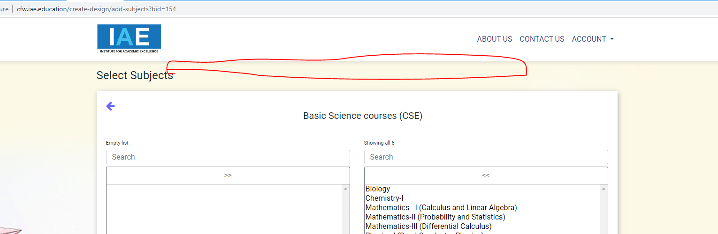

1. If we click on the back button, it is going to first page directly, please fix the issue.

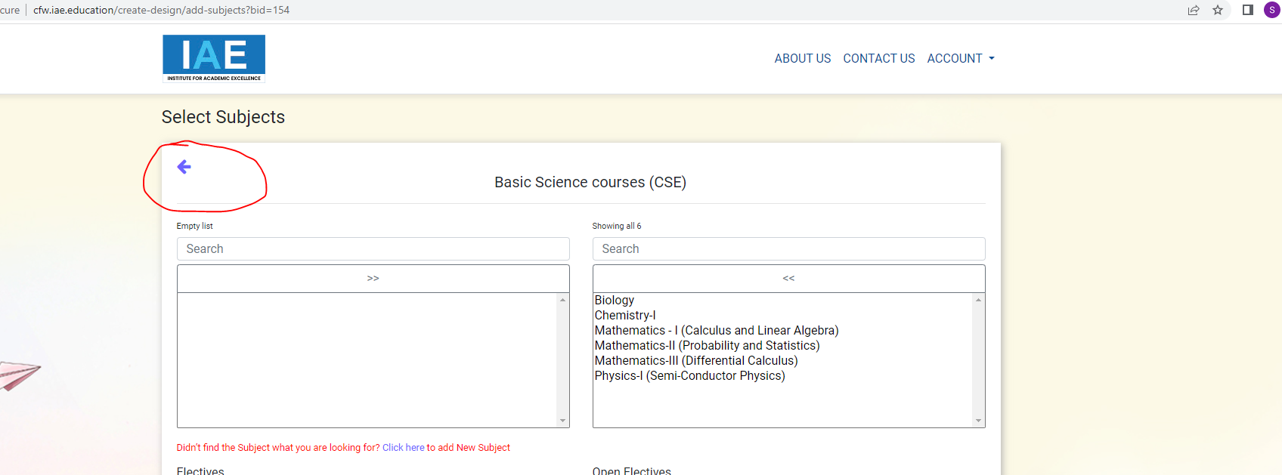

1. Please add a new column (input box) here to enter the Category Code by the Institution, this code is for this branch and this institution only. It should be displayed till the final screen and also in pdf files. 4 hrs (Done)

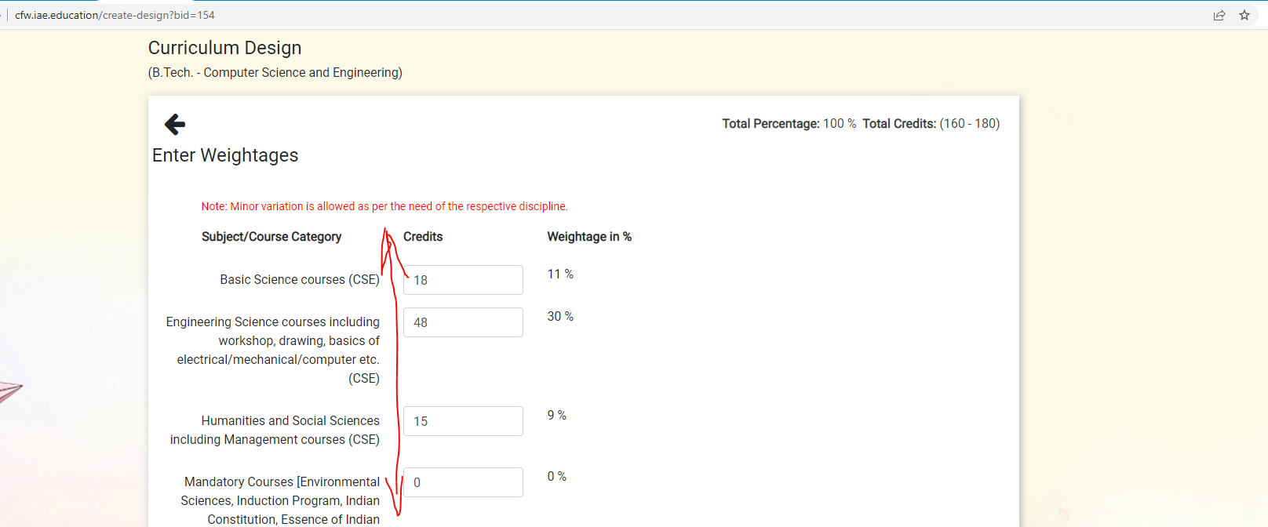

1. Remove brackets and it shouldbe ‘Under Graduate Program’ - Bachelor of Technology… 30min (Done)

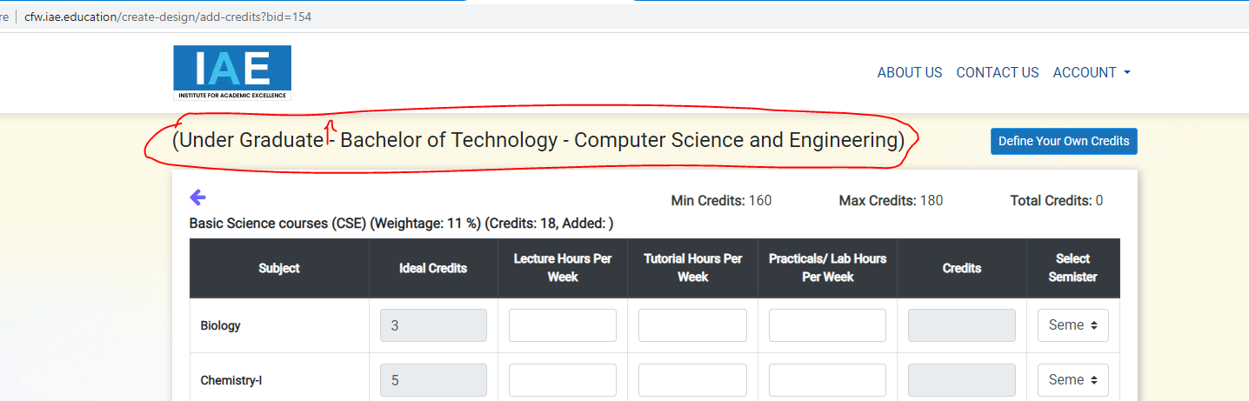

1. Add an input box to enter ‘Course Code’ by the Institution, that entered code is for this course and this institution only. It should be displayed till the final screen and also in pdf files. 8 hrs **( Done)**

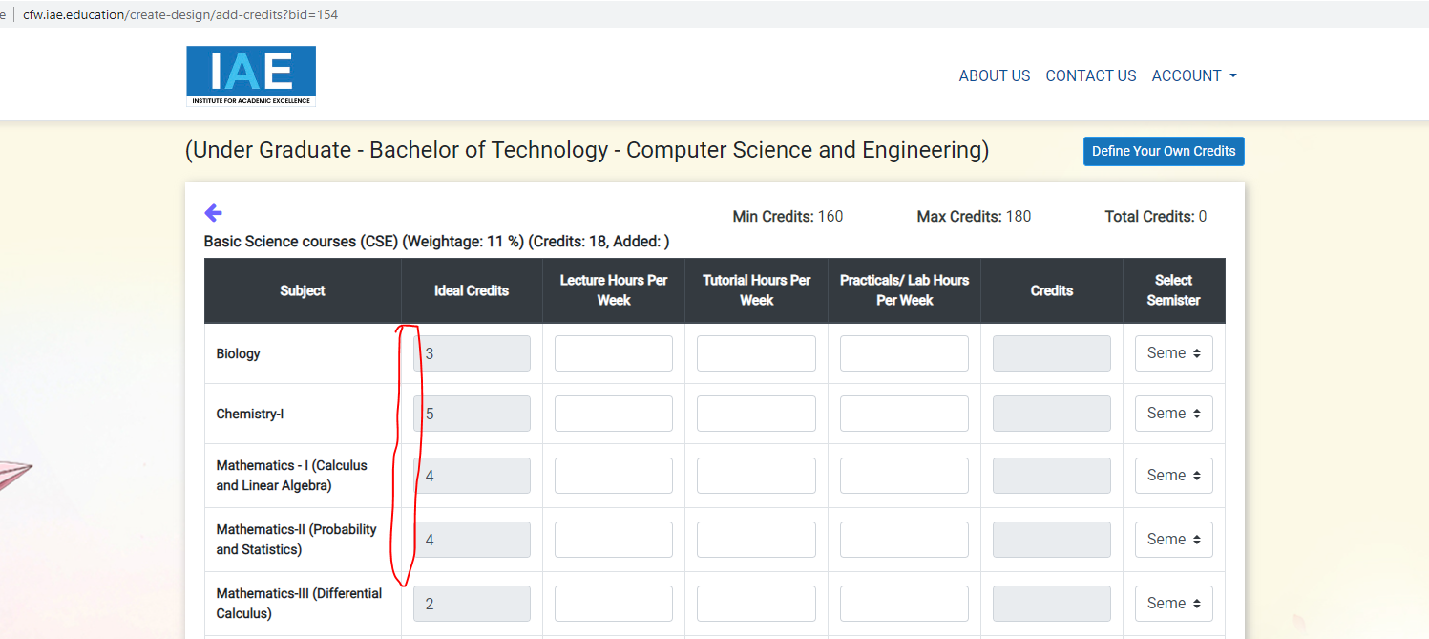

1. Please rename it as ‘AICTE Norms and Requirement’ instead of Instructions 30min (Done)

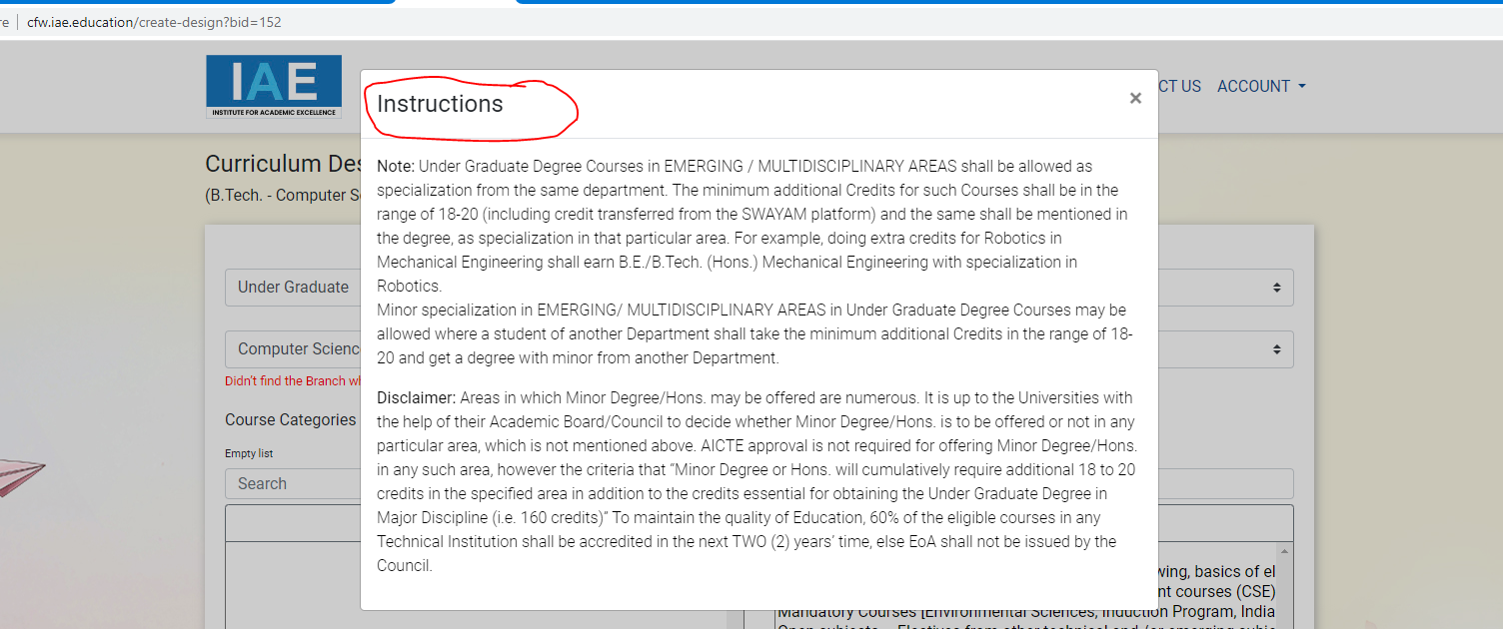

1. In the download PDF file… 8hrs **( Done)**
   1. Name of the Institutions should be displayed
   2. Remove brackets for program-course-branch and display them in 3 separate lines
   3. Remove min & max credits
   4. Display the weightage & credits in second line
   5. Table lines must be single and neat
   6. Change the Subject as Course
   7. Remove Ideal Credits column
   8. Display the totals of 4 columns (L/T/P & Credits)
   9. Add the following columns
      1. Sl. No.,
      2. Course Category
      3. Course Category Code
      4. Course Code (after the Course column)
   10. Make the values in the table to center alignment.
   11. Make all these changes in the Semester wise pdf also.
   12. In semester wise pdf semesters are displaying not in a sequence, please display them in the sequence.

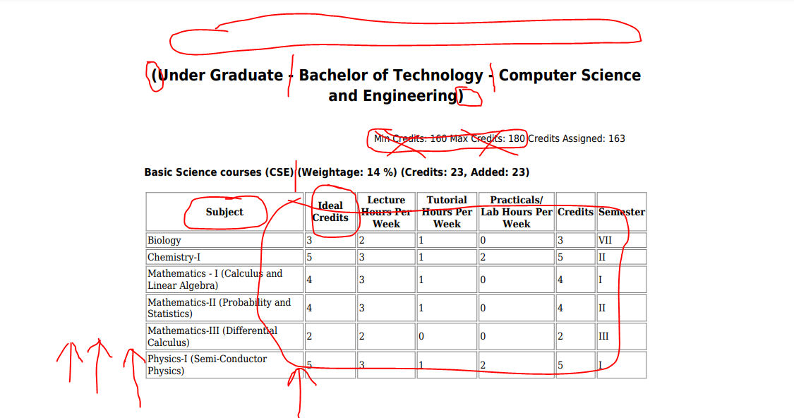

1. I added a new Branch, but unable to add new course categories in that new branch because it is not showing the categories below. But if I start the creation process from the beginning, it is showing the category box, please fix this issue. 1 hr(Done)

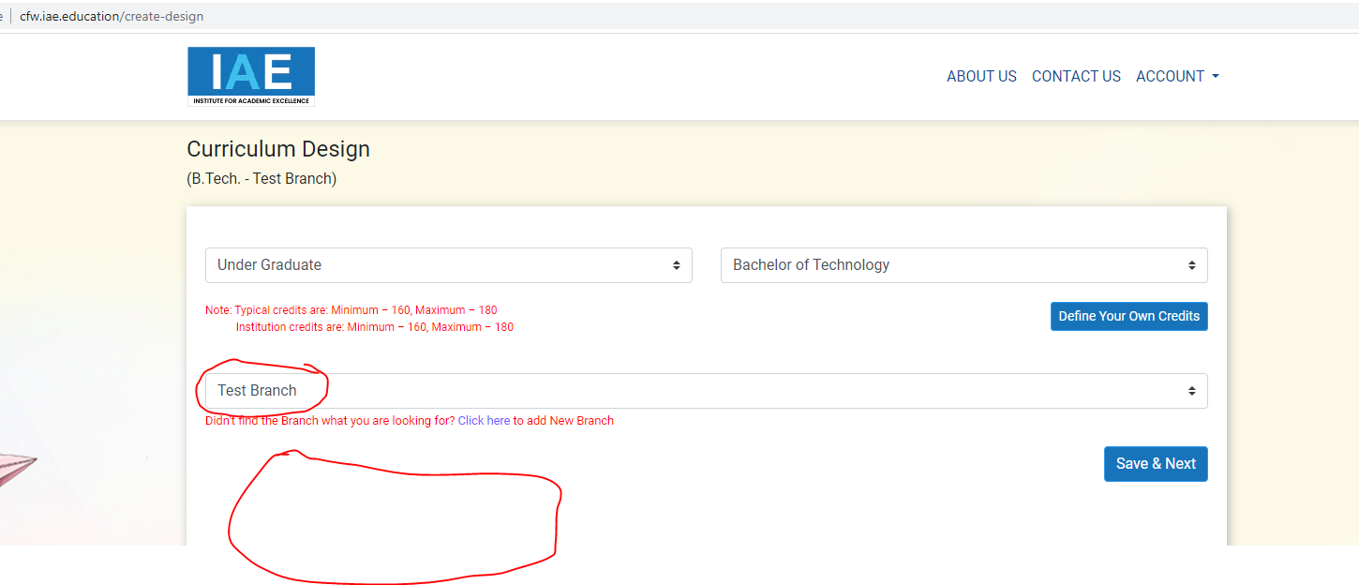

1. Change subject category -> course category, course -> course title, add category code in semester wise pdf.